**Code for Decision Tree**

import numpy as np

import pandas as pd

import warnings

warnings.simplefilter("ignore")

import numpy as np

import pandas as pd

import seaborn as sns

import matplotlib.pyplot as plt

plt.style.use('ggplot')

%matplotlib inline

mushrooms = 'C:/Users/Jonathan/Downloads/mushrooms.csv'

dataset=pd.read_csv(mushrooms)

X=dataset.drop('class',axis=1) #Predictors

y=dataset['class'] #True values for prediction class

X.head()

| **cap-shape** | **cap-surface** | **cap-color** | **bruises** | **odor** | **gill-attachment** | **gill-spacing** | **gill-size** | **gill-color** | **stalk-shape** | **...** | **stalk-surface-below-ring** | **stalk-color-above-ring** | **stalk-color-below-ring** | **veil-type** | **veil-color** | **ring-number** | **ring-type** | **spore-print-color** | **population** | **habitat** |
| --- | --- | --- | --- | --- | --- | --- | --- | --- | --- | --- | --- | --- | --- | --- | --- | --- | --- | --- | --- | --- |
| **0** | x | s | n | t | p | f | c | n | k | e | ... | s | w | w | p | w | o | p | k | s | u |
| **1** | x | s | y | t | a | f | c | b | k | e | ... | s | w | w | p | w | o | p | n | n | g |
| **2** | b | s | w | t | l | f | c | b | n | e | ... | s | w | w | p | w | o | p | n | n | m |

5 rows × 22 columns

from sklearn.preprocessing import LabelEncoder

Encoder_X = LabelEncoder()

for col in X.columns:

X[col] = Encoder_X.fit_transform(X[col])

Encoder_y=LabelEncoder()

y = Encoder_y.fit_transform(y)

#Test data 30% of observations, Training set 70%

from sklearn.model_selection import train_test_split

X_train, X_test, y_train, y_test = train_test_split(X, y, test_size=0.3, random_state=42)

from sklearn.preprocessing import StandardScaler

sc = StandardScaler()

X_train = sc.fit_transform(X_train)

X_test = sc.transform(X_test)

from sklearn.decomposition import PCA

pca = PCA(n_components=2)

X_train = pca.fit_transform(X_train)

X_test = pca.transform(X_test)

---------------------------------------------For Visualizing Data-----------------------------------------------------------------

def visualization_train(model):

sns.set_context(context='notebook',font_scale=2)

plt.figure(figsize=(16,9))

from matplotlib.colors import ListedColormap

X_set, y_set = X_train, y_train

X1, X2 = np.meshgrid(np.arange(start = X_set[:, 0].min() - 1, stop = X_set[:, 0].max() + 1, step = 0.01),

np.arange(start = X_set[:, 1].min() - 1, stop = X_set[:, 1].max() + 1, step = 0.01))

plt.contourf(X1, X2, classifier.predict(np.array([X1.ravel(), X2.ravel()]).T).reshape(X1.shape),

alpha = 0.6, cmap = ListedColormap(('red', 'green')))

plt.xlim(X1.min(), X1.max())

plt.ylim(X2.min(), X2.max())

for i, j in enumerate(np.unique(y_set)):

plt.scatter(X_set[y_set == j, 0], X_set[y_set == j, 1],

c = ListedColormap(('red', 'green'))(i), label = j)

plt.title("%s Training Set" %(model))

plt.xlabel('PC 1')

plt.ylabel('PC 2')

plt.legend()

def visualization_test(model):

sns.set_context(context='notebook',font_scale=2)

plt.figure(figsize=(16,9))

from matplotlib.colors import ListedColormap

X_set, y_set = X_test, y_test

X1, X2 = np.meshgrid(np.arange(start = X_set[:, 0].min() - 1, stop = X_set[:, 0].max() + 1, step = 0.01),

np.arange(start = X_set[:, 1].min() - 1, stop = X_set[:, 1].max() + 1, step = 0.01))

plt.contourf(X1, X2, classifier.predict(np.array([X1.ravel(), X2.ravel()]).T).reshape(X1.shape),

alpha = 0.6, cmap = ListedColormap(('red', 'green')))

plt.xlim(X1.min(), X1.max())

plt.ylim(X2.min(), X2.max())

for i, j in enumerate(np.unique(y_set)):

plt.scatter(X_set[y_set == j, 0], X_set[y_set == j, 1],

c = ListedColormap(('red', 'green'))(i), label = j)

plt.title("%s Test Set" %(model))

plt.xlabel('PC 1')

plt.ylabel('PC 2')

plt.legend()

--------------------------------------------------End definition for Visualization------------------------------------------------

from sklearn.model_selection import cross_val_predict, cross_val_score

from sklearn.metrics import confusion_matrix,classification_report,accuracy_score

#def for printing scores in an easier to read manner

def print_score(classifier,X_train,y_train,X_test,y_test,train=True):

if train == True:

print("Training results:\n")

print('Accuracy Score: {0:.4f}\n'.format(accuracy_score(y_train,classifier.predict(X_train))))

print('Classification Report:\n{}\n'.format(classification_report(y_train,classifier.predict(X_train))))

print('Confusion Matrix:\n{}\n'.format(confusion_matrix(y_train,classifier.predict(X_train))))

res = cross_val_score(classifier, X_train, y_train, cv=10, n_jobs=-1, scoring='accuracy')

print('Average Accuracy:\t{0:.4f}\n'.format(res.mean()))

print('Standard Deviation:\t{0:.4f}'.format(res.std()))

elif train == False:

print("Test results:\n")

print('Accuracy Score: {0:.4f}\n'.format(accuracy_score(y_test,classifier.predict(X_test))))

print('Classification Report:\n{}\n'.format(classification_report(y_test,classifier.predict(X_test))))

print('Confusion Matrix:\n{}\n'.format(confusion_matrix(y_test,classifier.predict(X_test))))

#Creation of Decision Tree and Training

from sklearn.tree import DecisionTreeClassifier as DT

from sklearn.cross_validation import cross_val_score

classifier = DT(criterion='entropy',random_state=42)

classifier.fit(X_train,y_train)

---------------------------------------------------------Output------------------------------------------------------------------------

DecisionTreeClassifier(class_weight=None, criterion='entropy', max_depth=None,

max_features=None, max_leaf_nodes=None,

min_impurity_decrease=0.0, min_impurity_split=None,

min_samples_leaf=1, min_samples_split=2,

min_weight_fraction_leaf=0.0, presort=False, random_state=42,

splitter='best')

---------------------------------------------------------Output------------------------------------------------------------------------

print_score(classifier,X_train,y_train,X_test,y_test,train=True)

---------------------------------------------------------Output------------------------------------------------------------------------

Training results:

Accuracy Score: 1.0000

Classification Report:

precision recall f1-score support

0 1.00 1.00 1.00 2951

1 1.00 1.00 1.00 2735

avg / total 1.00 1.00 1.00 5686

Confusion Matrix:

[[2951 0]

[ 0 2735]]

---------------------------------------------------------Output------------------------------------------------------------------------

print_score(classifier,X_train,y_train,X_test,y_test,train=False)

---------------------------------------------------------Output------------------------------------------------------------------------

Test results:

Accuracy Score: 0.8970

Classification Report:

precision recall f1-score support

0 0.90 0.91 0.90 1257

1 0.90 0.89 0.89 1181

avg / total 0.90 0.90 0.90 2438

Confusion Matrix:

[[1139 118]

[ 133 1048]]

Average Accuracy: 0.8925

Standard Deviation: 0.0128

---------------------------------------------------------Output------------------------------------------------------------------------

visualization_train('Decision Tree')

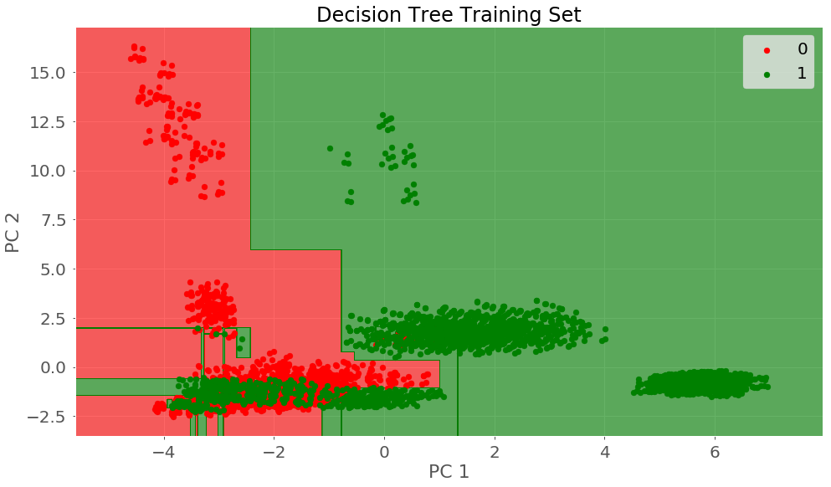

visualization_test('Decision Tree')

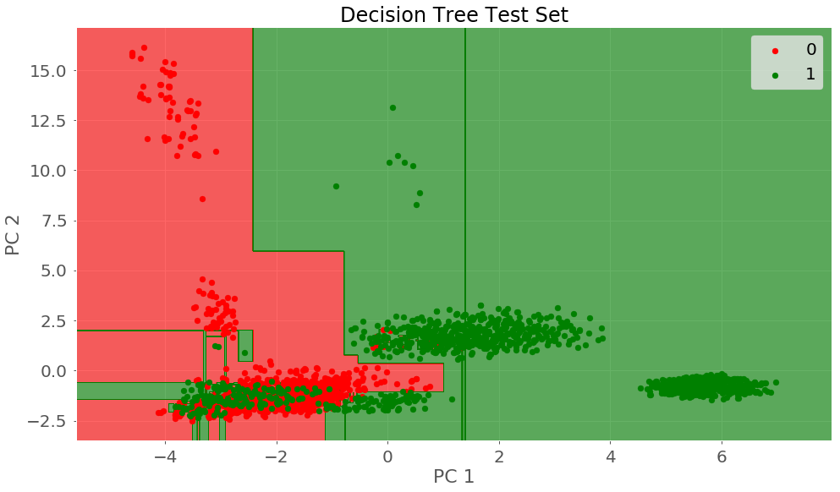

X_train, X_test, y_train, y_test = train_test_split(X, y, test_size=0.5, random_state=42)

classifier2 = DT(criterion='entropy',random_state=42)

classifier2.fit(X_train,y_train)

---------------------------------------------------------Output------------------------------------------------------------------------

DecisionTreeClassifier(class_weight=None, criterion='entropy', max_depth=None,

max_features=None, max_leaf_nodes=None,

min_impurity_decrease=0.0, min_impurity_split=None,

min_samples_leaf=1, min_samples_split=2,

min_weight_fraction_leaf=0.0, presort=False, random_state=42,

splitter='best')

---------------------------------------------------------Output------------------------------------------------------------------------

# testing with a 50/50 split

from sklearn.model_selection import train_test_split

X_train, X_test, y_train, y_test = train_test_split(X, y, test_size=0.5, random_state=45)

classifier2 = DT(criterion='entropy',random_state=42)

classifier2.fit(X_train,y_train)

print_score(classifier2,X_train,y_train,X_test,y_test,train=True)

---------------------------------------------------------Output------------------------------------------------------------------------

Training results:

Accuracy Score: 1.0000

Classification Report:

precision recall f1-score support

0 1.00 1.00 1.00 2097

1 1.00 1.00 1.00 1965

avg / total 1.00 1.00 1.00 4062

Confusion Matrix:

[[2097 0]

[ 0 1965]]

Average Accuracy: 1.0000

Standard Deviation: 0.0000

---------------------------------------------------------Output------------------------------------------------------------------------

print_score(classifier2,X_train,y_train,X_test,y_test,train=False)

---------------------------------------------------------Output------------------------------------------------------------------------

Test results:

Accuracy Score: 0.9990

Classification Report:

precision recall f1-score support

0 1.00 1.00 1.00 2111

1 1.00 1.00 1.00 1951

avg / total 1.00 1.00 1.00 4062

Confusion Matrix:

[[2111 0]

[ 4 1947]]

---------------------------------------------------------Output------------------------------------------------------------------------

**Code for K nearest Neighbor:**

import numpy as np # linear algebra

import pandas as pd # data processing, CSV file I/O (e.g. pd.read_csv)

from matplotlib import pyplot as plt

mushrooms = 'C:/Users/Jonathan/Downloads/mushrooms.csv'

data = pd.read_csv(mushrooms)

# seperating X vaules from y values

X= data.iloc[:,1:]

y = data.iloc[:,0]

from sklearn.preprocessing import LabelEncoder

from collections import defaultdict

d = defaultdict (LabelEncoder)

Xfit = X.apply(lambda x: d[x.name].fit_transform(x))

le_y = LabelEncoder()

yfit = le_y.fit_transform(y)

# for x in Xfit.columns:

# print(x)

# print(Xfit[x].value_counts())

import warnings

warnings.filterwarnings("ignore")

from sklearn.preprocessing import OneHotEncoder

ohc = defaultdict (OneHotEncoder)

# Xfit_ohc = Xfit.apply(lambda x: ohc[x.name].fit_transform(x))

final = pd.DataFrame()

for i in range(22):

# transforming the columns using One hot encoder

Xtemp_i = pd.DataFrame(ohc[Xfit.columns[i]].fit_transform(Xfit.iloc[:,i:i+1]).toarray())

#Naming the columns as per label encoder

ohc_obj = ohc[Xfit.columns[i]]

labelEncoder_i= d[Xfit.columns[i]]

Xtemp_i.columns= Xfit.columns[i]+"_"+labelEncoder_i.inverse_transform(ohc_obj.active_features_)

# taking care of dummy variable trap

X_ohc_i = Xtemp_i.iloc[:,1:]

#appending the columns to final dataframe

final = pd.concat([final,X_ohc_i],axis=1)

from sklearn.model_selection import train_test_split

X_train, X_test, y_train, y_test = train_test_split(final, yfit, test_size = 0.7, random_state = 0)

#testing k nearest neighbors w/ K = 30

from sklearn.neighbors import KNeighborsClassifier

classifier = KNeighborsClassifier(n_neighbors=30,p=2, metric='minkowski')

classifier.fit(X_train,y_train)

y_pred = classifier.predict(X_test)

from sklearn.metrics import confusion_matrix

cm= confusion_matrix(y_test,y_pred)

cm

---------------------------------------------------------Output 1------------------------------------------------------------------------

array([[2963, 5],

[ 6, 2713]], dtype=int64)

---------------------------------------------------------Output 1------------------------------------------------------------------------

from sklearn.metrics import accuracy_score

accuracy_score(y_test,y_pred)

---------------------------------------------------------Output 2------------------------------------------------------------------------

0.9980657640232108

---------------------------------------------------------Output 2------------------------------------------------------------------------

classif = KNeighborsClassifier(n_neighbors=4,p=2, metric='minkowski')

classif.fit(X_train,y_train)

y_pred = classif.predict(X_test)

accuracy_score(y_test,y_pred)

---------------------------------------------------------Output 3------------------------------------------------------------------------

0.9989449621944786

---------------------------------------------------------Output 3------------------------------------------------------------------------

from sklearn.model_selection import cross_val_score

# creating odd list of K for KNN

myList = list(range(1,4))

# empty list that will hold cv scores

cv_scores = []

# perform 10-fold cross validation

for k in myList[::2]:

knn = KNeighborsClassifier(n_neighbors=k)

scores = cross_val_score(knn, X_train, y_train, cv=10, scoring='accuracy')

cv_scores.append(scores.mean())

# changing to misclassification error

MSE = [1 - x for x in cv_scores]

# determining best k

optimal_k = myList[::2][MSE.index(min(MSE))]

print ("The optimal number of neighbors is %d" % optimal_k)

# plot misclassification error vs k

plt.plot(myList[::2], MSE)

plt.xlabel('Number of Neighbors K')

plt.ylabel('Misclassification Error')

plt.show()

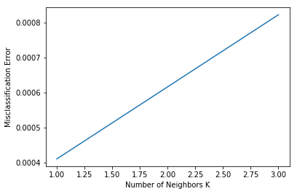

from sklearn.model_selection import cross_val_score

# creating odd list of K for KNN

myList = list(range(1,4))

# empty list that will hold cv scores

cv_scores = []

# perform 20-fold cross validation

for k in myList[::2]:

knn = KNeighborsClassifier(n_neighbors=k)

scores = cross_val_score(knn, X_train, y_train, cv=2, scoring='accuracy')

cv_scores.append(scores.mean())

# changing to misclassification error

MSE = [1 - x for x in cv_scores]

# determining best k

optimal_k = myList[::2][MSE.index(min(MSE))]

print ("The optimal number of neighbors is %d" % optimal_k)

# plot misclassification error vs k

plt.plot(myList[::2], MSE)

plt.xlabel('Number of Neighbors K')

plt.ylabel('Misclassification Error')

plt.show()

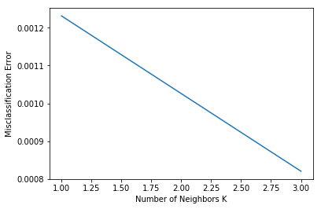

from sklearn.model_selection import train_test_split

X_train, X_test, y_train, y_test = train_test_split(final, yfit, test_size = 0.8, random_state = 0)

from sklearn.neighbors import KNeighborsClassifier

classifier = KNeighborsClassifier(n_neighbors=30,p=2, metric='minkowski')

classifier.fit(X_train,y_train)

y_pred = classifier.predict(X_test)

from sklearn.metrics import confusion_matrix

cm= confusion_matrix(y_test,y_pred)

cm

---------------------------------------------------------Output 4------------------------------------------------------------------------

array([[3313, 52],

[ 6, 3129]], dtype=int64)

---------------------------------------------------------Output 4------------------------------------------------------------------------

from sklearn.model_selection import cross_val_score

# creating odd list of K for KNN

myList = list(range(1,4))

# empty list that will hold cv scores

cv_scores = []

# perform 10-fold cross validation

for k in myList[::2]:

knn = KNeighborsClassifier(n_neighbors=k)

scores = cross_val_score(knn, X_train, y_train, cv=10, scoring='accuracy')

cv_scores.append(scores.mean())  
# changing to misclassification error

MSE = [1 - x for x in cv_scores]

# determining best k

optimal_k = myList[::2][MSE.index(min(MSE))]

print ("The optimal number of neighbors is %d" % optimal_k)

# plot misclassification error vs k

plt.plot(myList[::2], MSE)

plt.xlabel('Number of Neighbors K')

plt.ylabel('Misclassification Error')

plt.show()

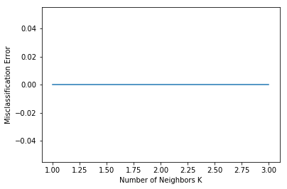

from sklearn.model_selection import cross_val_score

# creating odd list of K for KNN

myList = list(range(1,4))

# empty list that will hold cv scores

cv_scores = []

# perform 2-fold cross validation

for k in myList[::2]:

knn = KNeighborsClassifier(n_neighbors=k)

scores = cross_val_score(knn, X_train, y_train, cv=2, scoring='accuracy')

cv_scores.append(scores.mean())

# changing to misclassification error

MSE = [1 - x for x in cv_scores]

# determining best k

optimal_k = myList[::2][MSE.index(min(MSE))]

print ("The optimal number of neighbors is %d" % optimal_k)

# plot misclassification error vs k

plt.plot(myList[::2], MSE)

plt.xlabel('Number of Neighbors K')

plt.ylabel('Misclassification Error')

plt.show()



**#Linear Regression with PCA (Principle Component Analysis)**

pca_modified=PCA(n_components=17)

pca_modified.fit_transform(X)

---------------------------------------------------------Output 3----------------------------------------------------------------------

array([[-0.5743219 , -0.97578135, -1.22176154, ..., -0.51996599,

-0.78254366, 1.12025933],

[-2.2821023 , 0.27906633, -1.20049669, ..., -0.11307822,

-0.73093408, -0.01817413],

[-1.85803562, -0.27097236, -1.37237069, ..., 0.01652548,

-0.6561675 , 0.10791396],

...,

[-1.62151632, -0.75753671, 2.73357994, ..., -0.51961303,

-0.70768708, 0.22578534],

[ 3.67060561, -1.0327745 , 0.1684595 , ..., -0.08688401,

-0.11464249, -0.14801392],

[-1.57520272, -1.2285814 , 2.44722789, ..., 0.91606764,

-0.77988482, -0.30141893]])

---------------------------------------------------------Output 3----------------------------------------------------------------------

from sklearn.model_selection import train_test_split

X_train, X_test, y_train, y_test = train_test_split(X,y,test_size=0.2,random_state=4)

from sklearn.linear_model import LogisticRegression

from sklearn.model_selection import cross_val_score

from sklearn import metrics

#creating Logistical (Linear) Regression model

model_LR= LogisticRegression()

model_LR.fit(X_train,y_train)

---------------------------------------------------------Output----------------------------------------------------------------------

LogisticRegression(C=1.0, class_weight=None, dual=False, fit_intercept=True,

intercept_scaling=1, max_iter=100, multi_class='ovr', n_jobs=1,

penalty='l2', random_state=None, solver='liblinear', tol=0.0001,

verbose=0, warm_start=False)

---------------------------------------------------------Output----------------------------------------------------------------------

y_prob = model_LR.predict_proba(X_test)[:,1] # This will give you positive class prediction probabilities

y_pred = np.where(y_prob > 0.5, 1, 0) # This will threshold the probabilities to give class predictions.

model_LR.score(X_test, y_pred)

confusion_matrix=metrics.confusion_matrix(y_test,y_pred)

confusion_matrix

---------------------------------------------------------Output----------------------------------------------------------------------

array([[814, 31],

[ 37, 743]], dtype=int64)

---------------------------------------------------------Output----------------------------------------------------------------------

auc_roc=metrics.roc_auc_score(y_test,y_pred)

auc_roc

---------------------------------------------------------Output----------------------------------------------------------------------

0.9579388560157791

---------------------------------------------------------Output----------------------------------------------------------------------

from sklearn.metrics import roc_curve, auc

false_positive_rate, true_positive_rate, thresholds = roc_curve(y_test, y_prob)

roc_auc = auc(false_positive_rate, true_positive_rate)

roc_auc

---------------------------------------------------------Output----------------------------------------------------------------------

0.9902988924290701

---------------------------------------------------------Output----------------------------------------------------------------------

from sklearn.model_selection import cross_val_score

from sklearn import metrics

LR_model= LogisticRegression()

tuned_parameters = {'C': [0.001, 0.01, 0.1, 1, 10, 100, 1000] ,

'penalty':['l1','l2']

}

LR.fit(X_train,y_train)

y_prob = LR.predict_proba(X_test)[:,1] # This will give you positive class prediction probabilities

y_pred = np.where(y_prob > 0.5, 1, 0) # This will threshold the probabilities to give class predictions.

LR.score(X_test, y_pred)

confusion_matrix=metrics.confusion_matrix(y_test,y_pred)

confusion_matrix

---------------------------------------------------------Output----------------------------------------------------------------------

array([[824, 21],

[ 23, 757]], dtype=int64)

---------------------------------------------------------Output----------------------------------------------------------------------

auc_roc=metrics.roc_auc_score(y_test,y_pred)

auc_roc

---------------------------------------------------------Output----------------------------------------------------------------------

0.9728303747534518

---------------------------------------------------------Output----------------------------------------------------------------------

from sklearn.metrics import roc_curve, auc

false_positive_rate, true_positive_rate, thresholds = roc_curve(y_test, y_prob)

roc_auc = auc(false_positive_rate, true_positive_rate)

roc_auc

---------------------------------------------------------Output----------------------------------------------------------------------

0.991624943104233

---------------------------------------------------------Output----------------------------------------------------------------------

…..

…..

**#The same methods using only 2 cross validations and a new train test split 60/40, results outlined in report**

**Code for Non Linear Regression**

**Code for K Means**

dataset['class'].unique() # records unique occurrences in the class variable (poisonous vs edible)

dataset['stalk-color-above-ring'].unique() #unique values in this variable

…

X = dataset.iloc[:,1:23] # all rows, all the features and no labels

y = dataset.iloc[:, 0] # all rows, label only

…

dataset.corr() #prints table with the correlation between variables

# Scale the data to be between -1 and 1

from sklearn.preprocessing import StandardScaler

scaler = StandardScaler()

X=scaler.fit_transform(X)

X

---------------------------------------------------------Output 1----------------------------------------------------------------------

array([[ 1.02971224, 0.14012794, -0.19824983, ..., -0.67019486,

-0.5143892 , 2.03002809],

[ 1.02971224, 0.14012794, 1.76587407, ..., -0.2504706 ,

-1.31310821, -0.29572966],

[-2.08704716, 0.14012794, 1.37304929, ..., -0.2504706 ,

-1.31310821, 0.86714922],

...,

[-0.8403434 , 0.14012794, -0.19824983, ..., -1.50964337,

-2.11182722, 0.28570978],

[-0.21699152, 0.95327039, -0.19824983, ..., 1.42842641,

0.28432981, 0.28570978],

[ 1.02971224, 0.14012794, -0.19824983, ..., 0.16925365,

-2.11182722, 0.28570978]])

---------------------------------------------------------Output 1----------------------------------------------------------------------

from sklearn.decomposition import PCA

pca = PCA()

pca.fit_transform(X)

---------------------------------------------------------Output 2----------------------------------------------------------------------

array([[-5.74321902e-01, -9.75781349e-01, -1.22176154e+00, ...,

-2.08581362e-01, 8.13996758e-03, -2.98716006e-17],

[-2.28210230e+00, 2.79066333e-01, -1.20049669e+00, ...,

1.52238789e-01, -1.96446132e-01, 8.17047124e-17],

[-1.85803562e+00, -2.70972362e-01, -1.37237069e+00, ...,

2.57581784e-01, -3.62577199e-01, 3.62451933e-17],

...,

[-1.62151632e+00, -7.57536709e-01, 2.73357994e+00, ...,

-1.42532241e+00, 6.36990122e-01, 1.31607921e-18],

[ 3.67060561e+00, -1.03277450e+00, 1.68459501e-01, ...,

9.41440123e-02, -6.43462238e-02, -7.47641463e-20],

[-1.57520272e+00, -1.22858140e+00, 2.44722789e+00, ...,

-8.04626064e-01, 5.90315263e-01, 1.39554149e-19]])

---------------------------------------------------------Output 2----------------------------------------------------------------------

#plotting data on a scatterplot using the numerical transformation of the original data

N=dataset.values

pca = PCA(n_components=2)

x = pca.fit_transform(N)

plt.figure(figsize = (5,5))

plt.scatter(x[:,0],x[:,1])

plt.show()

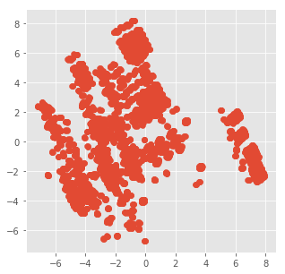

**# K = 2 clusters**

from sklearn.cluster import KMeans

kmeans = KMeans(n_clusters=2, random_state=5)

X_clustered = kmeans.fit_predict(N)

LABEL_COLOR_MAP = {0 : 'g',

1 : 'y',

2 : 'r',

3: 'b'

}

label_color = [LABEL_COLOR_MAP[l] for l in X_clustered]

plt.figure(figsize = (5,5))

plt.scatter(x[:,0],x[:,1], c= label_color)

plt.show()

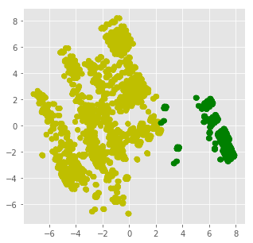

**#K = 3 Clusters**

kmeans = KMeans(n_clusters=3, random_state=5)

X_clustered = kmeans.fit_predict(N)

label_color = [LABEL_COLOR_MAP[l] for l in X_clustered]

plt.figure(figsize = (5,5))

plt.scatter(x[:,0],x[:,1], c= label_color)

plt.show()

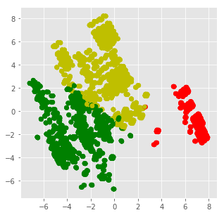

**#K = 4 clusters**

kmeans = KMeans(n_clusters=4, random_state=5)

X_clustered = kmeans.fit_predict(N)

label_color = [LABEL_COLOR_MAP[l] for l in X_clustered]

plt.figure(figsize = (5,5))

plt.scatter(x[:,0],x[:,1], c= label_color)

plt.show()

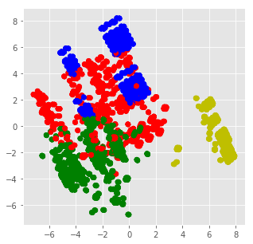

**Code for Hierarchical Clustering**

import matplotlib.pyplot as plt

import pandas as pd

%matplotlib inline

import numpy as np

mushrooms = 'C:/Users/Jonathan/Downloads/mushrooms.csv'

dataset=pd.read_csv(mushrooms)

from sklearn.preprocessing import LabelEncoder

labelencoder=LabelEncoder()

for col in dataset.columns:

dataset[col] = labelencoder.fit_transform(dataset[col])

X = dataset.iloc[:,0:23] # all rows, all the features and labels

---------------------------------------------------------Output 1----------------------------------------------------------------------

array([[ 1.0366127 , 1.02971224, 0.14012794, ..., -0.67019486,

-0.5143892 , 2.03002809],

[-0.96468045, 1.02971224, 0.14012794, ..., -0.2504706 ,

-1.31310821, -0.29572966],

[-0.96468045, -2.08704716, 0.14012794, ..., -0.2504706 ,

-1.31310821, 0.86714922],

...,

[-0.96468045, -0.8403434 , 0.14012794, ..., -1.50964337,

-2.11182722, 0.28570978],

[ 1.0366127 , -0.21699152, 0.95327039, ..., 1.42842641,

0.28432981, 0.28570978],

[-0.96468045, 1.02971224, 0.14012794, ..., 0.16925365,

-2.11182722, 0.28570978]])

---------------------------------------------------------Output 1----------------------------------------------------------------------

from sklearn.decomposition import PCA

pca = PCA()

pca.fit_transform(X)

---------------------------------------------------------Output 2----------------------------------------------------------------------

array([[-3.21350852e-01, -6.94030533e-01, -2.35421304e-01, ...,

-1.90098038e-01, 5.81245340e-02, 1.20049002e-17],

[-2.47697655e+00, -8.02019582e-02, 8.03020443e-01, ...,

1.23244655e-01, 1.37769748e-01, 9.15787295e-18],

[-2.17990553e+00, -7.70028186e-01, 6.17134078e-01, ...,

2.12242019e-01, 2.95473906e-01, 1.47857572e-17],

...,

[-1.89106512e+00, 1.51835675e-01, -1.59777499e+00, ...,

-1.40391995e+00, -8.22748173e-01, -4.11457227e-19],

[ 3.72914776e+00, -1.12122520e+00, -7.19805204e-01, ...,

9.64043340e-02, 9.85382596e-02, -6.65878887e-20],

[-1.94095417e+00, -3.97285454e-01, -1.73096408e+00, ...,

-7.62980716e-01, -6.46329807e-01, 6.05361613e-20]])

---------------------------------------------------------Output 2----------------------------------------------------------------------

import scipy.cluster.hierarchy as shc

plt.figure(figsize=(10, 7))

plt.title("Customer Dendograms")

dend = shc.dendrogram(shc.linkage(X, method='ward'))

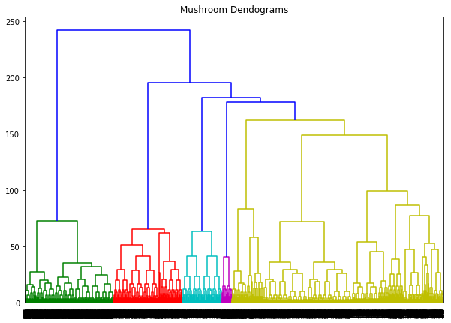

from sklearn.cluster import AgglomerativeClustering

cluster = AgglomerativeClustering(n_clusters=7, affinity='euclidean', linkage='ward')

cluster.fit_predict(X)

plt.figure(figsize=(10, 7))

plt.scatter(X[:,0], X[:,1], c=cluster.labels_, cmap='rainbow')

A scatter plot of 7 classes defined by the dendrogram

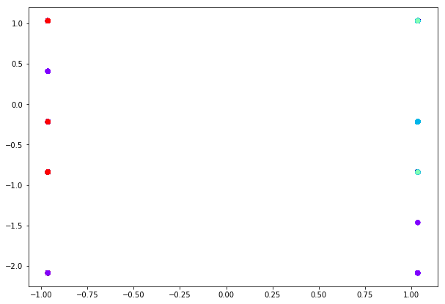

…. The same was repeated but excluding the class (poisonous vs edible ) in the data

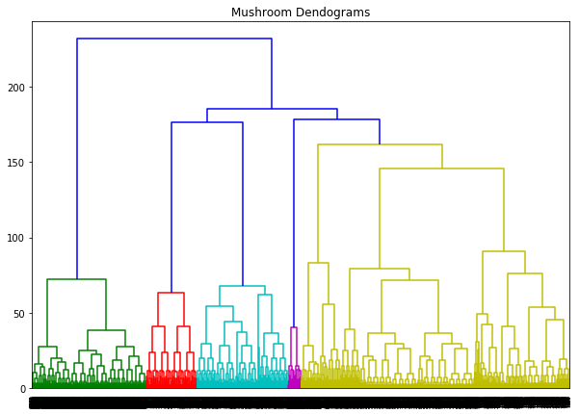

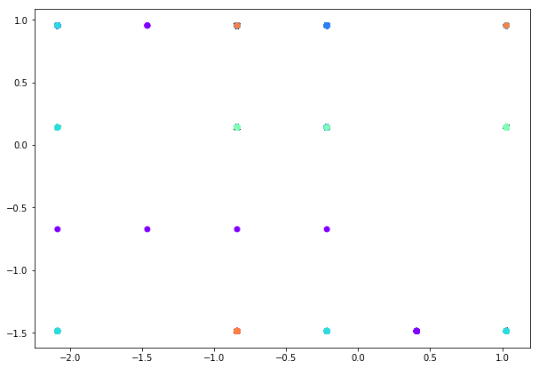

**Code for Neural Network :**

import numpy as np # linear algebra

import pandas as pd # data processing, CSV file I/O (e.g. pd.read_csv)

import matplotlib.pyplot as plt # data visualizations

from sklearn.preprocessing import LabelEncoder # label encoder

from sklearn.model_selection import train_test_split # Splitter

mushrooms = 'C:/Users/Jonathan/Downloads/mushrooms.csv'

df = pd.read_csv(mushrooms)

label_encoder = LabelEncoder()

df = df.apply(label_encoder.fit_transform) # label encoding

#

y = df["class"].values # our labels.. okay to eat or poison.

df.drop(["class"],axis=1,inplace=True) # dropping the lables from the data

df.drop(["veil-color"],axis=1,inplace=True)

df.drop(["veil-type"],axis=1,inplace=True)

x_data = df # our features..

x = (x_data - np.min(x_data))/(np.max(x_data)-np.min(x_data)).values # normalization

#

x_train, x_test, y_train, y_test = train_test_split(x, y, test_size=0.2, random_state=42) # 20% would be enough

x_train = x_train.values.T

x_test = x_test.values.T

y_train = y_train.reshape(-1,1).T

y_test = y_test.reshape(-1,1).T

def initialize_param(layers_with_nodes,in_data,out_data):

# we start with initializing the input layer's values.

layer_amount = len(layers_with_nodes)

parameters = {}

parameters["weight1"] = np.random.randn(layers_with_nodes[0],in_data.shape[0]) * 0.1

parameters["bias1"] = np.zeros((layers_with_nodes[0],1))

print("" + str(layer_amount+2) + " layers. (" + str(layer_amount) + " hidden layer)")

# then we initialize the hidden layer's values.

for i in range(layer_amount-1):

#print(i+2)

w = "weight" + str(i+2)

b = "bias" + str(i+2)

parameters[w] = np.random.randn(layers_with_nodes[i+1],layers_with_nodes[i]) * 0.1

parameters[b] = np.zeros((layers_with_nodes[i+1],1))

# and lastly output layer's values.

lastw = "weight" + str(layer_amount+1)

lastb = "bias" + str(layer_amount+1)

parameters[lastw] = np.random.randn(out_data.shape[0],layers_with_nodes[layer_amount-1]) * 0.1

parameters[lastb] = np.zeros((out_data.shape[0],1))

return parameters, (layer_amount+1)

def sigmoid(x):

y_head = 1/(1 + np.exp(-x)) # basic sigmoid for output layer

return y_head;

def compute_cost(A_f, y_train):

logprobs = np.multiply(np.log(A_f),y_train)

cost = -np.sum(logprobs)/y_train.shape[1] # computing the loss value, so we can improve our success more in the future.

return cost

def forw_prop_NN(in_data, parameters, connection_amount):

cache = {}

a0 = in_data

# forward propagation until last layer is same because we use tanh for all except output layer.

for i in range(connection_amount-1):

w = "weight" + str(i+1)

b = "bias" + str(i+1)

z = "Z" + str(i+1)

a = "A" + str(i+1)

cache[z] = np.dot(parameters[w],a0) + parameters[b]

cache[a] = np.tanh(cache[z])

a0 = cache[a]

# then on the output(last) layer we use sigmoid.

z_fin = "Z" + str(connection_amount)

a_fin = "A" + str(connection_amount)

w = "weight" + str(connection_amount)

b = "bias" + str(connection_amount)

a0 = "A" + str(connection_amount-1)

cache[z_fin] = np.dot(parameters[w],cache[a0]) + parameters[b]

cache[a_fin] = sigmoid(cache[z_fin])

A = cache[a_fin]

return A, cache

def backw_prop_NN(parameters,cache,x_train,y_train,connection_amount):

dz = {}

grads = {}

# since we are going backwards on back propagation, we update values from last to first

# so firstly we will start with output layer.

a_fin = "A" + str(connection_amount)

a_pre_fin = "A" + str(connection_amount-1)

w_fin = "dweight" + str(connection_amount)

b_fin = "dbias" + str(connection_amount)

dz[connection_amount] = cache[a_fin] - y_train

grads[w_fin] = np.dot(dz[connection_amount],cache[a_pre_fin].T)/x_train.shape[1]

grads[b_fin] = np.sum(dz[connection_amount], axis=1, keepdims=True)/x_train.shape[1]

# then continue with the rest of layers.

for i in range((connection_amount-1),1,-1):

a = "A" + str(i)

a_pre = "A" + str(i-1)

dw = "dweight" + str(i)

db = "dbias" + str(i)

w = "weight" + str(i+1)

dz[i] = np.dot(parameters[w].T,dz[i+1])*(1 - np.power(cache[a], 2))

grads[dw] = np.dot(dz[i],cache[a_pre].T)/x_train.shape[1]

grads[db] = np.sum(dz[i], axis=1,keepdims=True)/x_train.shape[1]

dz[1] = np.dot(parameters["weight2"].T,dz[2])*(1 - np.power(cache["A1"], 2))

grads["dweight1"] = np.dot(dz[1],x_train.T)/x_train.shape[1]

grads["dbias1"] = np.sum(dz[1],axis =1,keepdims=True)/x_train.shape[1]

return grads

def update_param(parameters, grads, connection_amount, lr=0.01):

for i in range(connection_amount):

w = "weight" + str(i+1)

b = "bias" + str(i+1)

dw = "dweight" + str(i+1)

db = "dbias" + str(i+1)

parameters[w] = parameters[w] - lr*grads[dw]

parameters[b] = parameters[b] - lr*grads[db]

return parameters # basic update for all layers...

def predict(A,parameters,x_test,connection_amount):

# x_test is a input for forward propagation

A, cache = forw_prop_NN(x_test,parameters,connection_amount)

Y_prediction = np.zeros((1,x_test.shape[1]))

for i in range(A.shape[1]):

if A[0,i]<= 0.5:

Y_prediction[0,i] = 0

else:

Y_prediction[0,i] = 1

return Y_prediction # basic binary prediction...

def multi_layer_model(layers_with_nodes,x_train,y_train,x_test,y_test, num_iter, lr = 0.01): # only learning rate is pre-defined

cost_list = []

index_list = []

parameters, connection_amount = initialize_param(layers_with_nodes, x_train, y_train) # starting with initializing for only once

# then do the following part for each iteration..

for i in range(0, num_iter):

# forward propagation

A, cache = forw_prop_NN(x_train,parameters,connection_amount)

# compute cost

cost = compute_cost(A, y_train)

# backward propagation

grads = backw_prop_NN(parameters,cache,x_train,y_train,connection_amount)

# update parameters

parameters = update_param(parameters, grads, connection_amount, lr)

if i % 100 == 0:

cost_list.append(cost)

index_list.append(i)

print ("Cost after iteration %i: %f" %(i, cost))

plt.plot(index_list,cost_list)

plt.xticks(index_list,rotation='vertical')

plt.xlabel("Number of Iterarion")

plt.ylabel("Cost")

plt.show()

# predict

y_prediction_train = predict(A, parameters, x_train, connection_amount)

y_prediction_test = predict(A, parameters, x_test, connection_amount)

# Print train/test Errors

print("train accuracy: {} %".format(100 - np.mean(np.abs(y_prediction_train - y_train)) * 100))

print("test accuracy: {} %".format(100 - np.mean(np.abs(y_prediction_test - y_test)) * 100))

multi_layer_model([20,4],x_train,y_train,x_test,y_test,num_iter=3001,lr=0.03)

# the first array is where we desing our net for hidden layers.

# for example layers_with_nodes=[4] means one hidden layer with 4 nodes, or layers_with_nodes=[10,5] means two hidden layers: first layer with 10 and second with 5 nodes

# lr is learning rate as usual

# num_iter is number of iterations that we want our model to train.

---------------------------------------------------------Output ----------------------------------------------------------------------

4 layers. (2 hidden layer)

Cost after iteration 0: 0.335326

Cost after iteration 100: 0.345566

Cost after iteration 200: 0.345429

Cost after iteration 300: 0.325646

Cost after iteration 400: 0.271771

Cost after iteration 500: 0.205570

Cost after iteration 600: 0.165133

Cost after iteration 700: 0.143695

Cost after iteration 800: 0.127595

Cost after iteration 900: 0.114244

Cost after iteration 1000: 0.104820

Cost after iteration 1100: 0.098587

Cost after iteration 1200: 0.094336

Cost after iteration 1300: 0.091276

Cost after iteration 1400: 0.088947

Cost after iteration 1500: 0.087074

Cost after iteration 1600: 0.085482

Cost after iteration 1700: 0.084051

Cost after iteration 1800: 0.082702

Cost after iteration 1900: 0.081382

Cost after iteration 2000: 0.080058

Cost after iteration 2100: 0.078722

Cost after iteration 2200: 0.077383

Cost after iteration 2300: 0.076067

Cost after iteration 2400: 0.074805

Cost after iteration 2500: 0.073624

Cost after iteration 2600: 0.072538

Cost after iteration 2700: 0.071547

Cost after iteration 2800: 0.070640

Cost after iteration 2900: 0.069807

Cost after iteration 3000: 0.069032

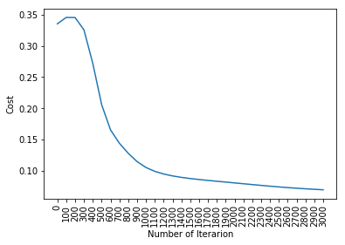

train accuracy: 96.26096322511155 %

test accuracy: 96.24615384615385 %

---------------------------------------------------------Output ----------------------------------------------------------------------

**Code for Naïve Bayes, Random Forest, and Support Vector Machine**

%matplotlib inline

%config InlineBackend.figure_format = 'retina'

import matplotlib.pyplot as plt

import seaborn as sns

import pandas as pd

import numpy as np

import math

mushrooms = 'C:/Users/Jonathan/Downloads/mushrooms.csv'

data = pd.read_csv(mushrooms)

Y = pd.get_dummies(data.iloc[:,0], drop_first=False)

X = pd.DataFrame()

for each in data.iloc[:,1:].columns:

dummies = pd.get_dummies(data[each], prefix=each, drop_first=False)

X = pd.concat([X, dummies], axis=1)

from sklearn.model_selection import train_test_split

X_train, X_test, y_train, y_test = train_test_split(X, Y, test_size=0.2, random_state=0)

from sklearn.naive_bayes import GaussianNB

from sklearn.svm import SVC

from sklearn.ensemble import RandomForestClassifier

models = []

models.append(('NB', GaussianNB()))

models.append(('SVM', SVC(probability=True)))

models.append(('RF', RandomForestClassifier()))

from sklearn.model_selection import cross_val_score, KFold

seed = 321

# evaluating each model in turn

results = []

names = []

for name, model in models:

kfold = KFold(n_splits=10, random_state=seed)

cv_results = cross_val_score(model, X_train, y_train.iloc[:,1], cv=kfold, scoring='roc_auc')

results.append(cv_results)

names.append(name)

msg = "%s: %f (%f)" % (name, cv_results.mean(), cv_results.std())

print(msg)

---------------------------------------------------------Output ----------------------------------------------------------------------

NB: 0.997965 (0.002335)

SVM: 0.999938 (0.000086)

RF: 1.000000 (0.000000)

---------------------------------------------------------Output ----------------------------------------------------------------------

# Compare Algorithms

fig = plt.figure(figsize=(16, 8))

fig.suptitle('Algorithm Comparison')

ax = fig.add_subplot(111)

plt.boxplot(results, vert=False)

ax.set_yticklabels(names)

plt.show()

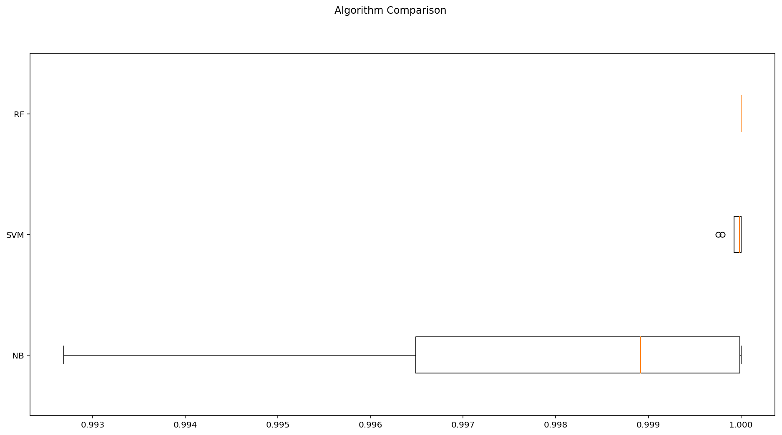

from collections import defaultdict

from sklearn.metrics import roc_auc_score

model_predictions = defaultdict()

model_score = defaultdict(np.float)

for name, model in models:

model.fit(X_train, y_train.iloc[:,1])

my_pred = model.predict(X_test)

model_predictions[name] = my_pred

model_score[name] = roc_auc_score(y_test.iloc[:,1], my_pred)

msg = "%s: %f" % (name, model_score[name])

print(msg)

model_predicions_df = pd.DataFrame(model_predictions)

corrmat = model_predicions_df.corr()

corrmat

---------------------------------------------------------Output ----------------------------------------------------------------------

NB: 0.989437

SVM: 1.000000

RF: 1.000000

|  | **NB** | **SVM** | **RF** |
| --- | --- | --- | --- |
| **NB** | 1.000000 | 0.978058 | 0.978058 |
| **SVM** | 0.978058 | 1.000000 | 1.000000 |
| **RF** | 0.978058 | 1.000000 | 1.000000 |